**Gym management software for Fitness Centers :**

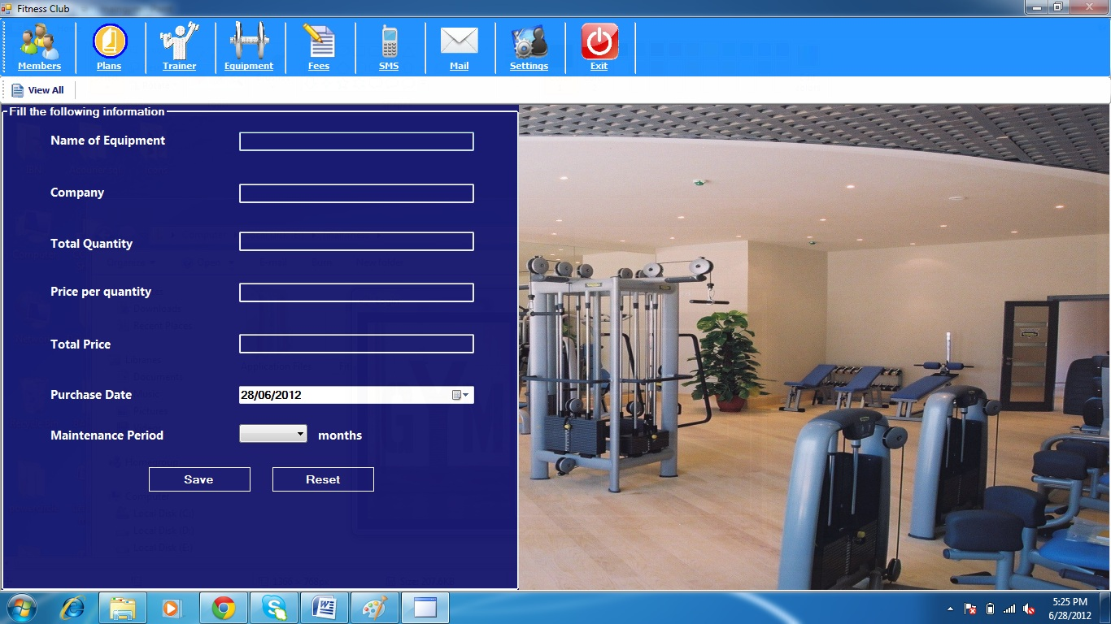

* Inbotics Pvt. Ltd introduces a new Revolutionary Management Software for Fitness Centers
* Tracking customers, Membership types, Member Check-In, Member photos, Membership freezes, One touch billing, Demographics, Who owes you money...
* Product management, Flexible discounts, Sales tabs, Gift cards, Scanning UPC Barcodes, Inventory, Receipt printers, Cash drawers, One touch buttons...
* Outlook style scheduling, Multiple Resources, Participant Lists, Event Recurrence, Classes, Clients, Web based portal...
* Flexible reporting, Export to Excel or PDF formats, Web dashboards give you instant stats, Build your own reports and queries...

feature has been carefully thought out and developed by a team of highly qualified IT professionals to suit

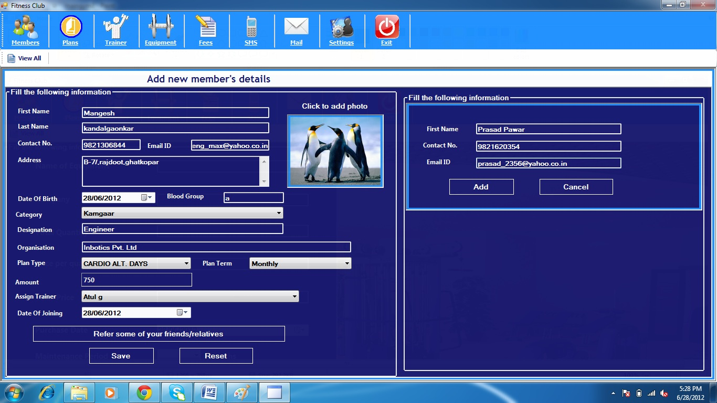

our needs.

This Software Contains Following Features

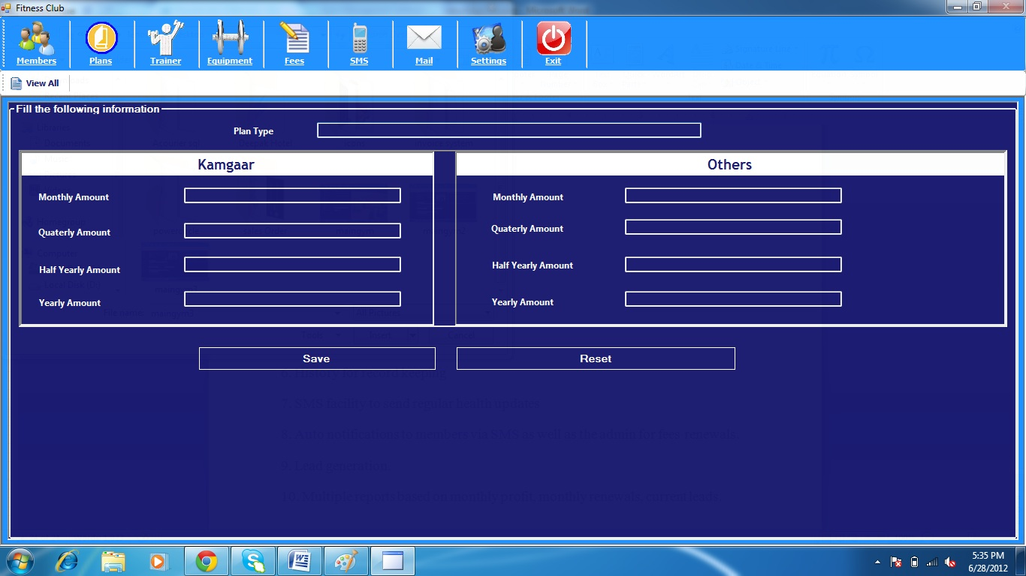

Following are the features

1. Add membership details

2. Add plans

3. Add Instructors

4. Add Equipments

5. Add transactions

6. History for record keeping

7. SMS facility to send regular health updates

8. Auto notifications to members via SMS as well as the admin for fees renewals.

9. Lead generation.

10. Multiple reports based on monthly profit, monthly renewals, current leads.

11. Attendance of trainers by Fingerprint authentication Machine

12. Automatic Salary Calculation by their Record of the Month

13. Fingerprint Module for Customer and trainers attendance

14. Monthly ,Yearly Report of Customers and Trainers Attendance

And many More

**Estimated Quotation:**

|  |  |
| --- | --- |
| Topic | Total R.s |
| 1. Gym Management Software with Fingerprint attendance Module   ( 1 Year Subscription) | 20,000 R.s |
| 1. Annual Maintenance Contract after 1 Year | 12% |
| Total | 20,000 r.s |

We look forward for Your Positive response

Thanking You,

Mangesh v. Kandalgaonakar.

( Relationship Manager)

+91-9821306844

Email: mangeshk@inbotics.com

[www.inbotics.com](http://www.inbotics.com)

[info@inbotics.com](mailto:info@inbotics.com)

+91-8652034232

Phone:+91-9619621683